### 

### **EFFECTS OF TIME SPENT ON SOCIAL MEDIA TO THE ANXIETY LEVEL AS THE CAUSE OF DEPRESSION OF CITCS STUDENTS**

Desamito, Julianne

Orbino, Michael

Soriano, Ajireh Ramielle

CITCS-1C

Julie Sabatchi Cuanso

Instructor

### 

### **Background of the Study**

Social networking sites (SNSs) are Web-based platforms on which individuals connect with other users to generate and maintain social connections. Considerable disagreement exists as to associations that SNS use may have with depression and anxiety. On the one hand, SNSs may protect from mental illness, as they support and enable social interaction and connection, and allow users to reflect aspects of their identity and express emotions that may be relevant to their lived experience . On the other hand, there are many opportunities for miscommunication and mismanaged expectations, and maladaptive tendencies can be exaggerated, leaving individuals feeling a greater sense of isolation. As a whole, the SNS environment may be just as complex as face-to-face interactions. As SNS membership continues to rise, it is becoming increasingly important to address the possible benefits and detriments the use of SNSs may have on mental health.

**Objectives of the Study:**

1. To identify the effects of spending time on Social Media to the Anxiety Level of CITCS students.

2. To determine how often CITCS students use Social Media that can lead to an increase or decrease in time spent.

3. To determine what Social Media Site is often used by CITCS students and their purpose of use.

performance of first year CITCS students.

Affective disorders such as depression and anxiety have been shown to have bidirectional interactions with the social environment that influence the path of illness onset and maintenance . Depression and anxiety have an approximate prevalence of 4.7% and 7.3%, respectively, in the global population . These disorders have high levels of comorbidity and impact the quality of social relationships . Depression and anxiety may be implicated in determining the size and structure of an individual’s social network, the quality of interactions within these networks, and how effectively social capital may be leveraged or developed to provide an individual with social support .

**Identifying the Variables:**

1. Categorical Variables
   1. Gender (Male and Female)
   2. Course (Information Technology and Computer Science)
   3. Social Media Sites (Facebook, Twitter, Instagram, Twitter etc.)
   4. Reasons for Using Social Media
   5. Likert Scaling for Anxiety Level
2. Quantitative Variables
   1. Age
   2. Time Spent (was also categorized in ranges 1 - 4)
   3. Number of days per week access on Social Media
   4. Individual Questions Anxiety Scores
   5. Total Anxiety Score

The social characteristics (both qualitative and structural) affected by depression or anxiety are also relevant to one’s sense of well-being. Current mental health theories suggest that the presence of well-being is not the same as the absence of mental illness; a complete model of mental health requires not just the absence of psychopathology, but also a focus on positive indices of functioning such as subjective well-being . This is particularly pertinent when exploring how the social environment may affect an individual, as such environments may simultaneously confer a number of benefits to the individual and exaggerate deficits.

**Hypothesis:**

**Null Hypothesis**, The time spent on social media has no effect on student's anxiety level

**Alternative Hypothesis**, The use of social media has an effect on student's anxiety level

Social aspects of the Internet have been argued to augment social relationships and support mental health. SNSs in particular connect us to friends, family, colleagues, strangers, and celebrities and can help users to maintain and make new friendships, express thoughts and feelings, and express identity . The primary social functions that SNSs perform may augment the benefits of engaging in face-to-face interaction by extending the reach and accessibility of our social networks . Indeed, SNS use is associated with lower levels of loneliness and greater feelings of belonging (social connectedness), social capital, and actual and perceived access to social support and is generally associated with higher levels of life satisfaction and self-esteem .

As a whole, the positive social components of SNS use suggest a protective role against depression and anxiety. For instance, higher levels of self-esteem and life satisfaction may aid in attenuating depressive symptoms.

For individuals with depression or anxiety, the interpretation and frequent exposure to this emotion may have a negative impact. SNS use may increase an individual’s exposure to negative social interactions (eg, cyberbullying), which may negatively impact mood and mental health . For example, negative interaction quality was associated with decreases in self-esteem and life satisfaction . Even passive exposure to the language used in SNS posts has been shown to influence the emotive language subsequently expressed by the receiving SNS user, where positive or negative emotions are argued to transfer via contagion. As SNSs explicitly support a number of social features, the relationships and interactions between the user, their emotional experience, and Web-based technology are likely to be complex and may even accentuate differences between those who are doing well in life and those who are struggling.

Cognitive and social factors frequently emerge as both moderators and mediators of the relationships between offline social interactions or events and depression and might also occur in Web-based environments. For instance, self-esteem mediates the pathway between relationship interactions and depressive symptoms, but it might also moderate how a person uses and is affected by the SNS. Rumination, a response style where an individual maintains a passive and repetitive focus on their distress , is one mechanism linking stressful life events and the development or maintenance of depression , and the SNS environment provides opportunity for a person to both internally ruminate on bad events and have an entire social network further accentuate shortcomings. Social support has additionally been shown to moderate relationships between stress and depression, with greater levels of social support acting as a buffer to depressive symptoms . This is pertinent to SNSs as they present a potential intervention opportunity for developing and strengthening supportive social networks for vulnerable individuals.

**Methodology**

The population of present study includes College of Information Technology and Computer Science Students of the University of the Cordilleras. In addition, the Likert scale is used in answering the anxiety table. The sample of 80 students are given questionnaires like the one below:

Good Day, we are 1st year students from the CITCS Department currently taking up the course Computer Science. As of now, we are conducting a research on the **“EFFECTS OF SOCIAL MEDIA ON STUDENTS ANXIETY LEVEL AS THE CAUSE OF DEPRESSION.”** Please answer the following in regards to you as a social media user. Thank you for your Time and Consideration.

**Name**(optional):________________________________________________________ **Age:**______ **Course:** ____________ **Gender:**_____________

1 How much time do you spend on Social Media Sites (whole day/24hrs).

A. Less than 1 hour

B. 1-2 hours

C. 3-4 hours

D. More than 4 hours E. Specify if you want:____________

2. What Social Media Sites do you use? (Can choose multiple)

◘ Facebook ◘ Snapchat ◘ Twitter◘ Instagram

◘Others:________________

3. Why do you use Social Media? (Can choose multiple)

◘ Entertainment

◘ Business Purposes

◘ Communication / Socializing

◘ Announcement / News

◘ Others: ___________________

4. When do you usually use social media

◘ at night ◘ after class ◘ during class ◘ freetime ◘ weekends

5. In a week how many days you use social media

A.1-2

B.3-4

C.5-6

D.Always

(1-Strongly disagree, 2-Moderately disagree, 3-Neither agree nor disagree, 4-Moderately agree, 5-strongly agree)

|  |  |
| --- | --- |
| **Questions :** | **Range:** |
| 1.Social media is part of my everyday activity. |  |
| 2.I feel out of touch when I haven’t logged into my social media sites for a while . |  |
| 3.I feel I am part of my social media community. |  |
| 4.I would be sorry if social media sites down. |  |
| 5.I am more comfortable using this social media sites . |  |
| 6.I found it difficult to relax . |  |
| 7.I found it difficult to work up the initiative to do things . |  |
| 8.I face hesitation before personally communicating with others people. |  |
| 9.I consider myself as a person with low confidence. |  |
| 10.I am easily annoyed or irritable. |  |
| 11.I always feel afraid as if something awful might happen.  12. I tend to overreact to situations. |  |

**Findings of the Study**

Graphs and Interpretations

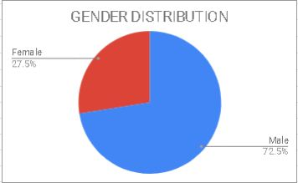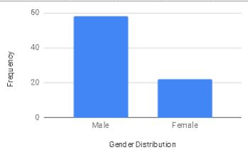

Interpretation: On our study the researchers more Male respondents

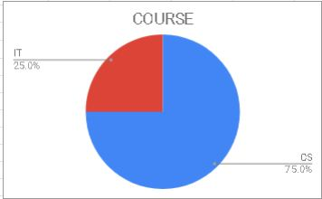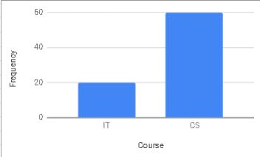

Interpretation: Most of the respondents are which has a percentage of 75 from CS.

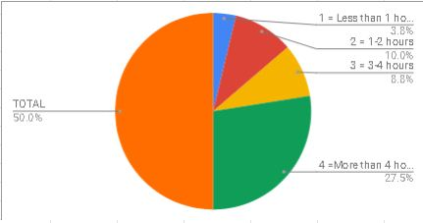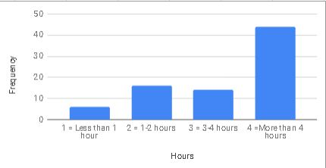

Interpretation: The respondents mostly uses Social media sites more than 4 hours.

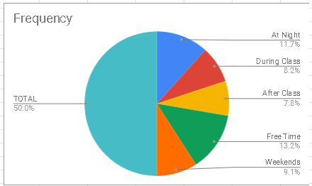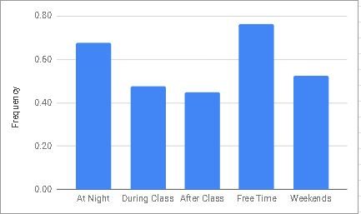

Interpretation: The respondents mostly uses social media sites at night or freetime.

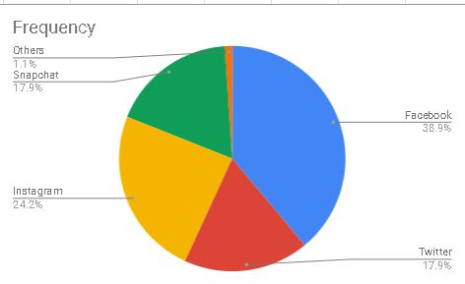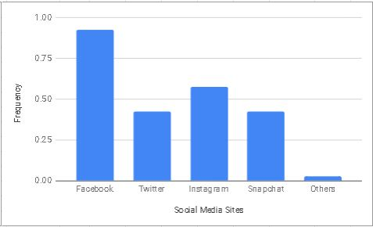

Interpretation: Facebook is the most used social media site from the data the researchers have gathered with the respondents.

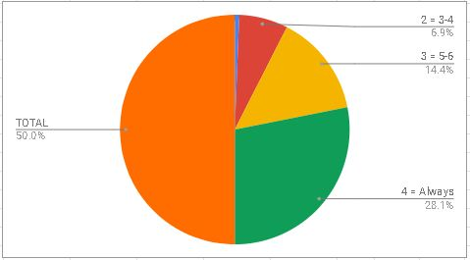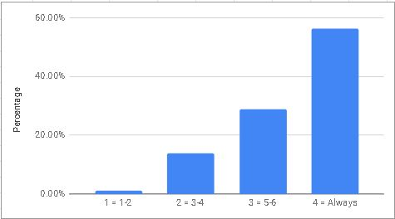

Interpretation: Most of the respondents always uses Social Media sites.

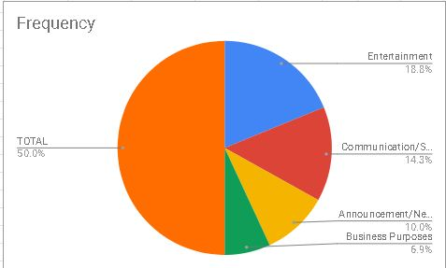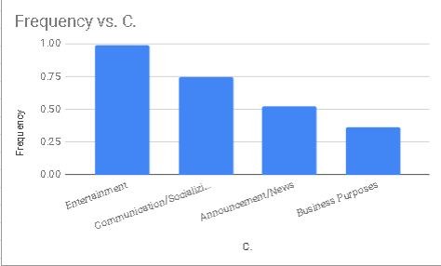

Interpretation: The main reasons from our respondents are just for Entertainment.

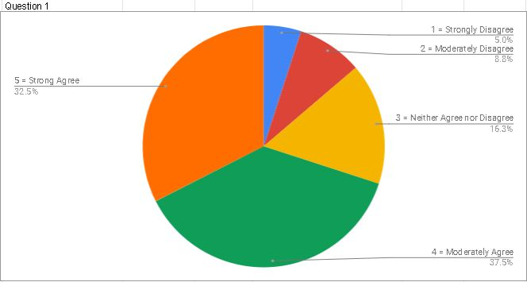

Interpretation: 37.5% is the highest percentage acquired from the respondents which is(Moderately agree).

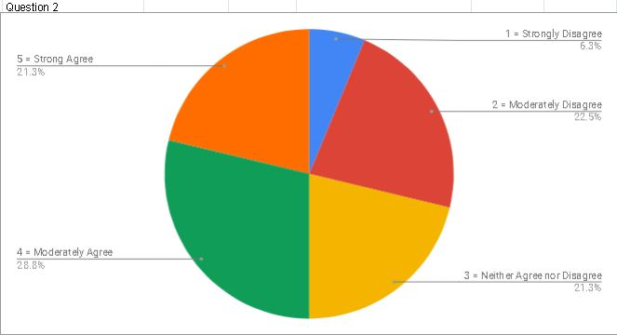

Interpretation: Most of the respondents feel that they are left out when they haven’t logged in to social media sites that they are using.

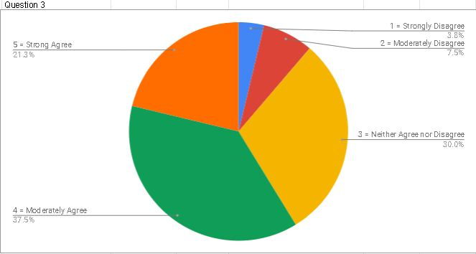

Interpretation:37.5 of the respondents feel that they are a part of the social media community.

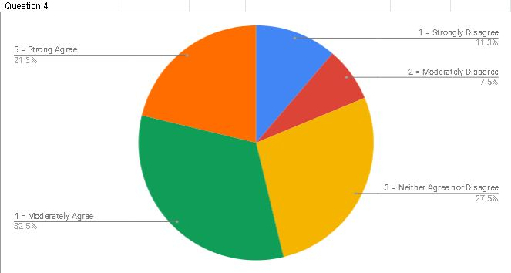

Interpretation: 32.5% says that they will be just moderately sorry if the social media site they are using is down system and only 11.3 is strongly disagreed.

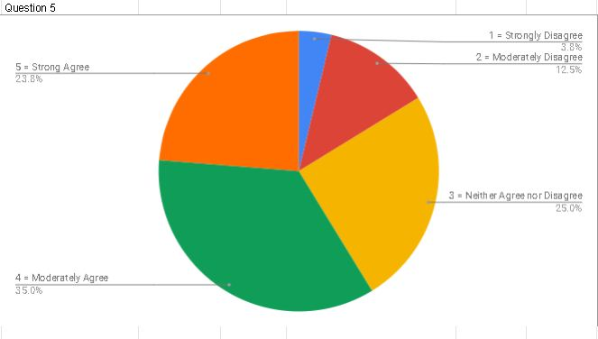

Interpretation: Nearly half of the respondents (35%) feel moderately comfortable when using social media which is the highest.

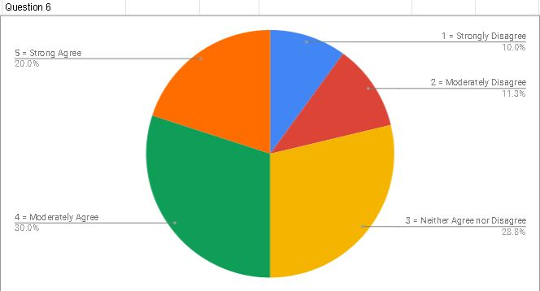

Interpretation: 30% of our respondents says that they are moderately having a hard time relaxing when using social media.

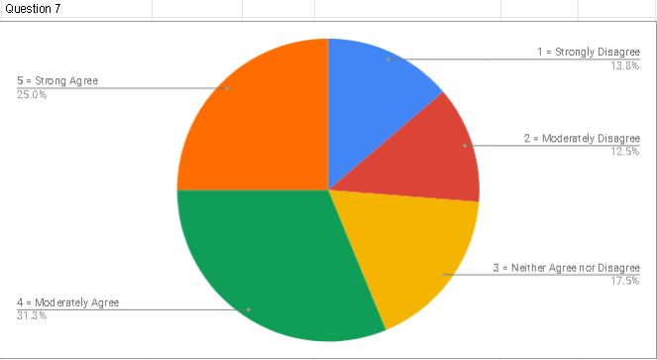

Interpretation: 31.3% says that they cannot focus on the other things they are doing when using social media.

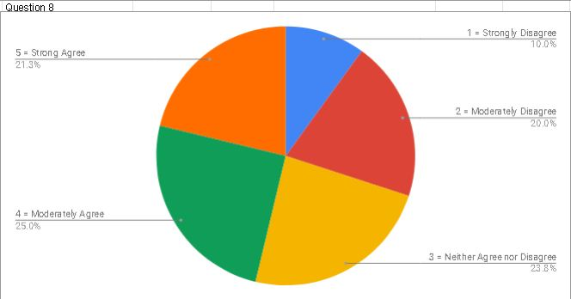

Interpretation: 25% say that they are shy to communicate with other people when using social media.

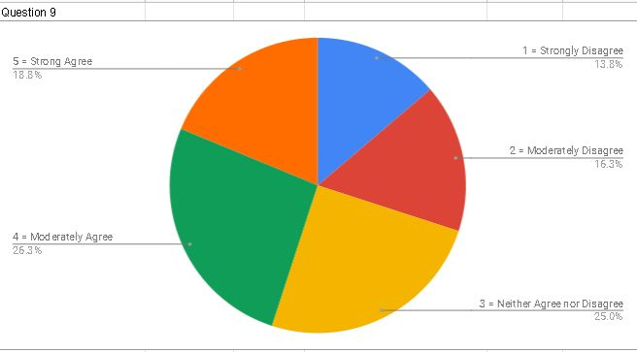

Interpretation: 26.3% says that they consider their self as someone who has low confidence.

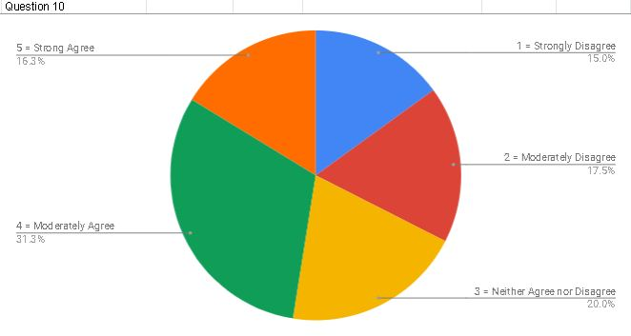

Interpretation:31.3% of the respondents said that they are easily annoyed or irritated when using social media sites.

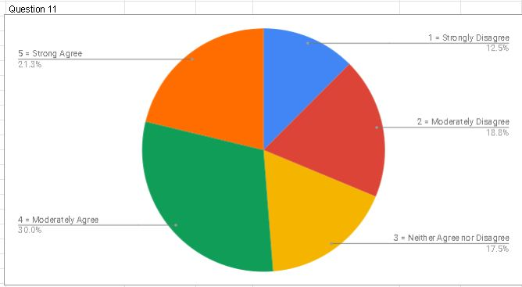

Interpretation:30% of the respondents said that they are somehow afraid that something might happen when they are using Social media Sites.

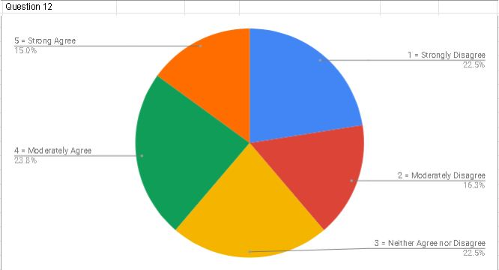

Interpretation:23.3 of the respondents said that they are sometimes tend to over-react on the things or situations they see in Social Media Sites.

**Assessment Tools**

1. Social Media Addiction Sale - The addiction scale contains four checkboxes. Each choice refers to the following
   1. Less than 1 hour..........Normal User
   2. 1-2 hours..........Slightly Addicted User
   3. 3-4 hours..........Addicted Users
   4. More than 4 hours........Severely Addicted Users
2. Beck Anxiety Inventory - question multiple-choice self-report inventory that is used for measuring the severity of anxiety in children and adults.
   1. 0-15 Low Anxiety
   2. 16-30 Mild Anxiety
   3. 31-45 Moderate Anxiety
   4. 46-60 High Anxiety

**Cross Tabulations**

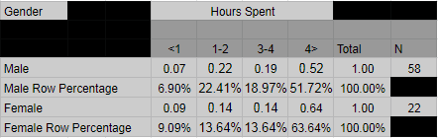

Interpretation: for the Male the highest answer we the researchers got is 4 hours (0.52%) which is 0.52% and for the female 0.64 (63.64).

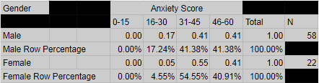

Interpretation: we the researchers got the most percentage of anxiety at 31-45 which has a 41.38% for male and 54.55% for females.

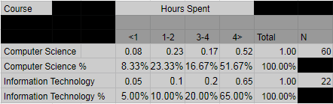

Interpretation: IT(information technology) got the most hours spent using social media sites which has a 0.65 (65%) score.

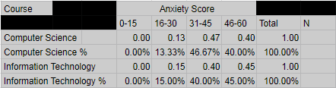

Interpretation: CS(Computer Science) got the most anxiety level at 31-45 which has a score of 0.47 (47%).

**Pearson Correlation Coefficient**

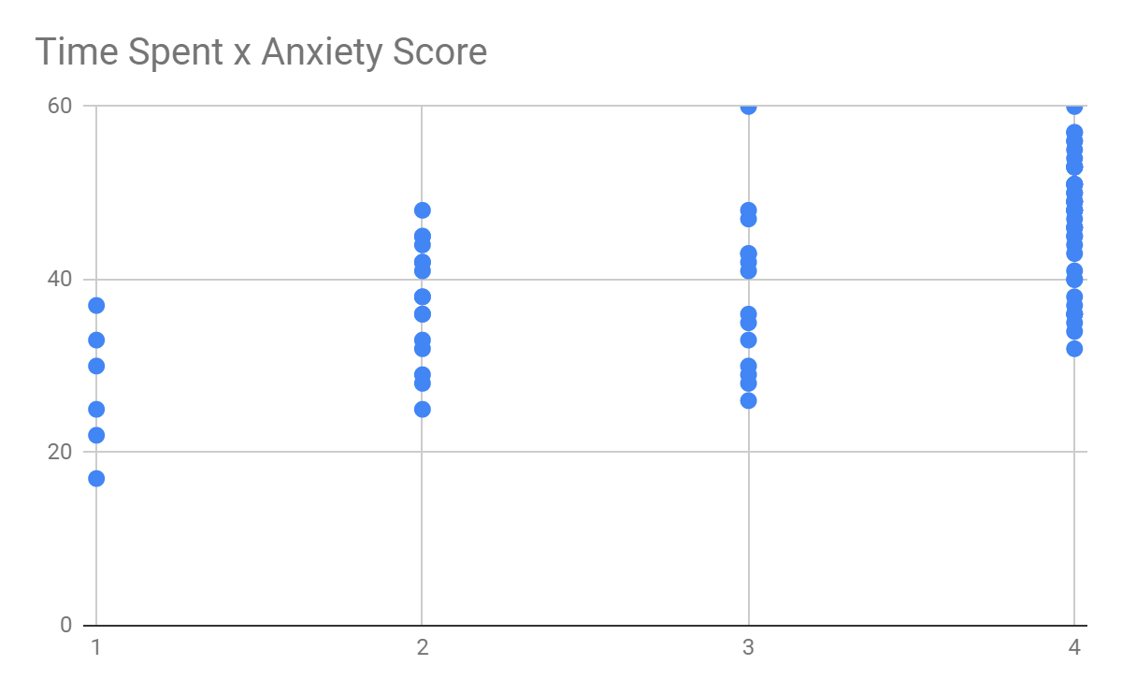

R = 0.6091378607 (Moderate Positive Correlation)There is a moderate uphill relationship between the Time Spent and the Total Anxiety Level Score of the students, which means that as the number of time spent increases the total anxiety score also increases.

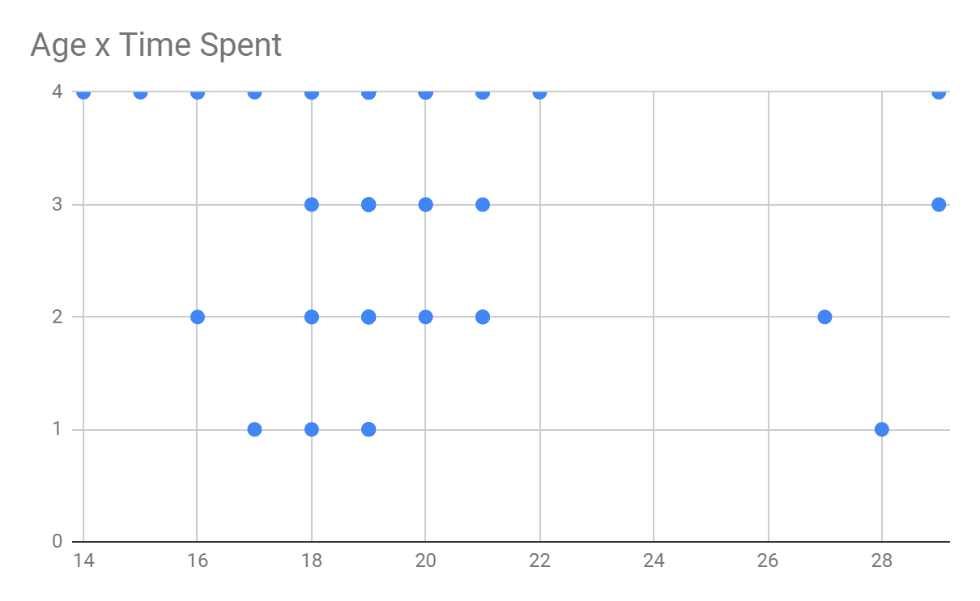

R = -0.1268592296 (Negligible Correlation) The relationship between the student’s Age and Average time spent on Social Media is considered insignificant. Most of the Respondents are at the age of 19 which is our X variable.

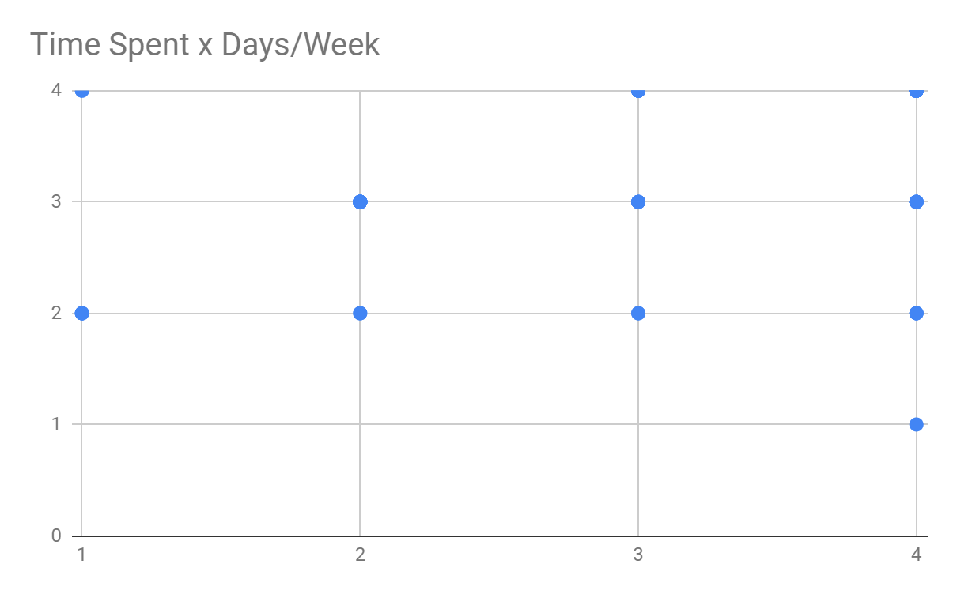

R= 0.4793083903 (Low Positive Correlation) X variable (Time Spent) and Y variable (How many days a week do you use Social Media) are hardly related to each other though they still are somehow correlated in which as one variable increases the other also increases.

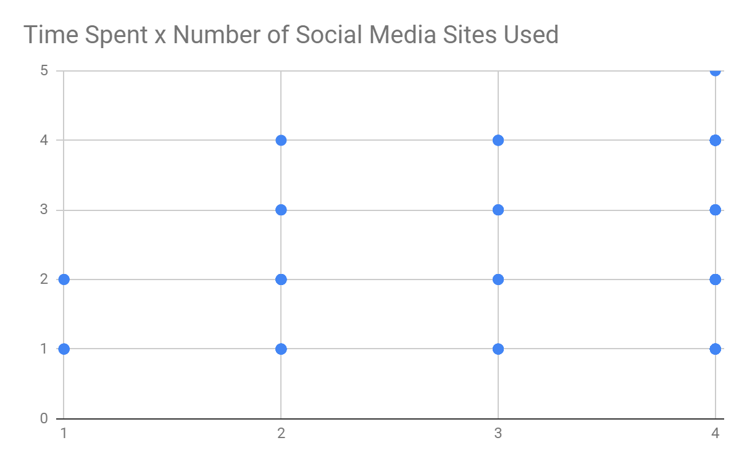

R = 0.3837699869 (Low Positive Correlation)X variable (Time Spent) and Y variable (Number of Social Media Sites Used) are hardly related to each other though they still are somehow correlated in which as one variable increases the chance for the other variable to increase as well.

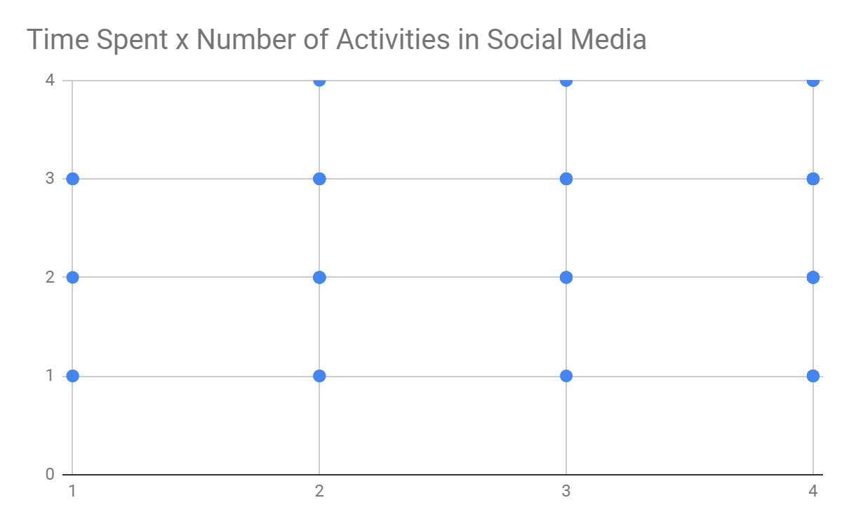

R = 0.218744752 (Negligible Correlation) The relationship between the student’s amount of time spent using Social Media and his Number of Activities in Social Media is considered insignificant.

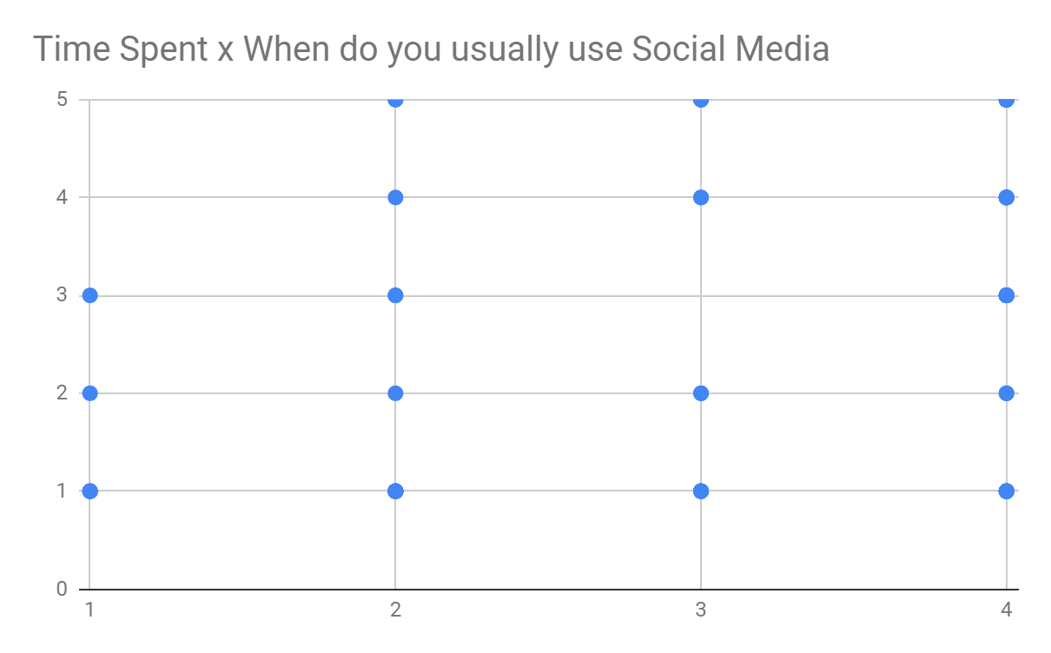

R = 0.4166431619 (Low Positive Correlation)X variable (Time Spent) and Y variable (How often do Students usually use Social Media) are hardly related to each other though they still are somehow correlated in which as one variable increases the chance for the other variable to increase as well.

**Test of Hypothesis**

The number of time spent is represented by Variable 1 while the mode from anxiety scores are based from the modes of each question ranging from 1 - 5 are represented by Variable 2.

*H0 = The time spent on social media has no effect on student's anxiety level*

*Ha = The use of social media has an effect on student's anxiety level*

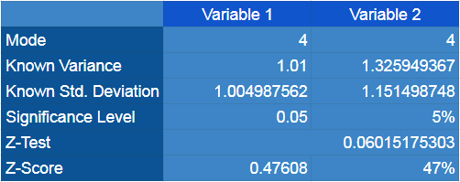

P-value = 0.06015175303

Since the P-value is greater than 0.05, there is strong evidence against H0. Therefore, the Total Time Spent on Social Media has an effect to CITCS Students Anxiety Level.

**Conclusions and Recommendations**

Since both the Pearson Coefficient Correlation and Test Hypothesis state the same results, the researchers therefore conclude that if CITCS students spend more time on Social Media, then there is a high chance their anxiety level will also increase, with this anxiety can lead to depression therefore Social Media is a factor that can affect the students Anxiety Level as the cause of Depression.

For future studies, the researchers suggest a higher range of values for the time spent in which can give an even more accurate results, this can also lead to higher r-value between Time Spent and Anxiety Score for Higher Positive Association between the two.

**Reflection**

We the researchers have proven that the more you use social media sites (fb, ig, twitter, snapchat etc.). Gives you a higher tendency to have anxiety because of the things you might see or read in the different sites that you are using. This study is a good excuse on why we should lessen our time in accessing social media sites. It’s not just a waste of time but it can also affect our mental health.

### Reference (Background of the Study) :

[JMIR Ment Health](https://www.ncbi.nlm.nih.gov/pmc/articles/PMC5143470/#). 2016 Oct-Dec; 3(4): e50.

Published online 2016 Nov 23. doi: [102196/mental.5842](https://dx.doi.org/10.2196%2Fmental.5842)